Chapter 11, Solution 95

- Source impedance 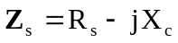
Load impedance 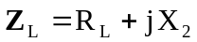

For maximum load transfer
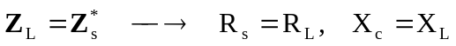
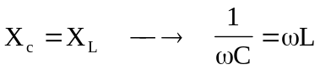
or 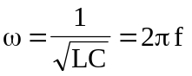

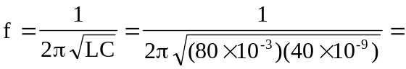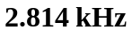

- 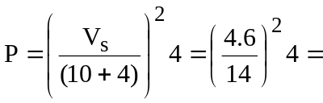 431.8 mW (since 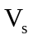 is in rms)

